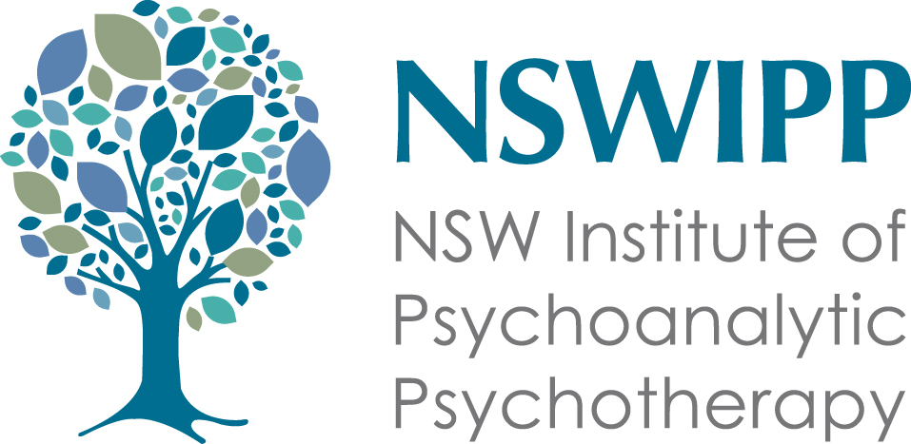

TRAINING IN PSYCHOANALYTIC PSYCHOTHERAPY

NSW Institute of Psychoanalytic Psychotherapy



This PROSPECTUS is an Introduction to the TRAINING PROGRAM in INDIVIDUAL PSYCHOANALYTIC PSYCHOTHERAPY offered by the NSW Institute of Psychoanalytic Psychotherapy.

NSWIPP is a professional association which represents psychoanalytic psychotherapists in NSW and the ACT. It is a member association of the Psychoanalytic Psychotherapy Association of Australasia (PPAA).

This prospectus is intended as an outline of the Training Program. It is not an exhaustive statement of the contents of the training. Nor should it be taken as the final arbiter of requirements of trainees, as NSWIPP may change training and membership requirements from time to time.

Contents
- Our training Program
- Application process
- Support for Trainees
- Progression to Membership
- Costs

Introduction
- NSWIPP offers intensive training in adult psychoanalytic psychotherapy. Completion of the training provides the foundation for a lifelong development as a psychoanalytic psychotherapist. The successful completion of this training will allow a trainee to apply for full membership of the NSWIPP.
- The NSWIPP Training Course has been running since 1978 and is administered by the Adult Training Advisory Board (ATAB). The course is regularly reviewed to ensure that we are offering a comprehensive, contemporary, high standard training to equip our trainees to practice psychoanalytic psychotherapy.
- The training is open to professionals from various disciplines including Psychiatrists, Psychologists, Social Workers, General Practitioners, Counsellors, Nurses and others, who hold a minimum of two years clinical experience. Other appropriate professional backgrounds may be considered by the ATAB (Adult Training Advisory Board).
- NSWIPP Training Program follows the traditional model of training for psychoanalytic psychotherapy operating throughout the Australian and international psychoanalytic psychotherapy communities (i.e. infant observation, didactic seminars, clinical supervision, and personal therapy). It follows the guidelines established by the Psychoanalytic Psychotherapy Association of Australasia (PPAA).
There are four concurrent strands to the training course:
- 1. personal psychoanalytic psychotherapy or psychoanalysis
- 2. infant observation
- 3. individual supervision of approved training cases
- 4. theoretical and clinical seminars
This concurrent experience allows a deeper understanding and integration of the theoretical knowledge, clinical practice, and the personal experience of psychoanalytic psychotherapy.

Our Training Program


Our training program uses current technology to provide state-wide access to our training by offering hybrid online learning for our seminar programs.

The developing clinical experience of the trainee is an important focus of the teaching, which is conducted in small groups.
Our program is specifically designed to enable trainees to develop the knowledge, skills and attitude to work clinically, ethically and competently as psychoanalytic psychotherapists.
As a trainee, and then as a future member, you will have a professional home that links you to the wider psychotherapeutic community and to ongoing professional development opportunities. You will be part of a stimulating and supportive environment with professional colleagues, a focus on lifelong learning and development.
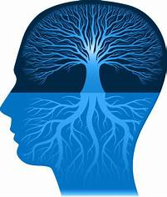
Aims of Training:
- To develop an understanding of the psychoanalytic theory of human behaviour, emotional development, and mental life.
- To develop competence in the assessment and psychoanalytic psychotherapeutic treatment of adults.
- To develop an awareness of the scope and the limitations of various psychoanalytic psychotherapeutic approaches.
- To develop insight into transference and counter-transference and an understanding of the unconscious.
- To promote an awareness of the need for consultation with other professionals as a way of monitoring the treatment process, and to be able to use this consultation constructively to work collaboratively in the service of patients.
- To develop a high standard of ethical practice in the therapist’s interaction with the patient and with other professionals and professional bodies.
- To encourage in members a capacity to promote psychoanalysis, and a psychoanalytic perspective, within both the health and the broader community
The course aims to stimulate a process of life-long learning, which continues far beyond its duration, rather than to provide a definitive body of knowledge.
1. Personal Psychotherapy/Psychoanalysis
This is a foundational aspect of all psychoanalytically oriented training. Applicants are required, by the time of application, to be in an established therapy with a NSWIPP approved therapist. The therapist must belong to either NSWIPP or the Australian Psychoanalytic Society (APAS), or be a member of the PPAA. A minimum frequency of twice weekly therapy is required. Members of the ATAB are available to discuss this with you and provide a list of approved therapists, if needed.
This personal psychotherapy continues until the training requirements are completed. As this essential therapy is a highly confidential pursuit, the ATAB does not ask the training therapist for any reports regarding the Trainee, other than a commencement and completion date, which should be mutually agreed upon. Please note that Medicare rebates are not available for training therapies as per Medicare legislation, but the fees can be claimed as a professional tax deduction.

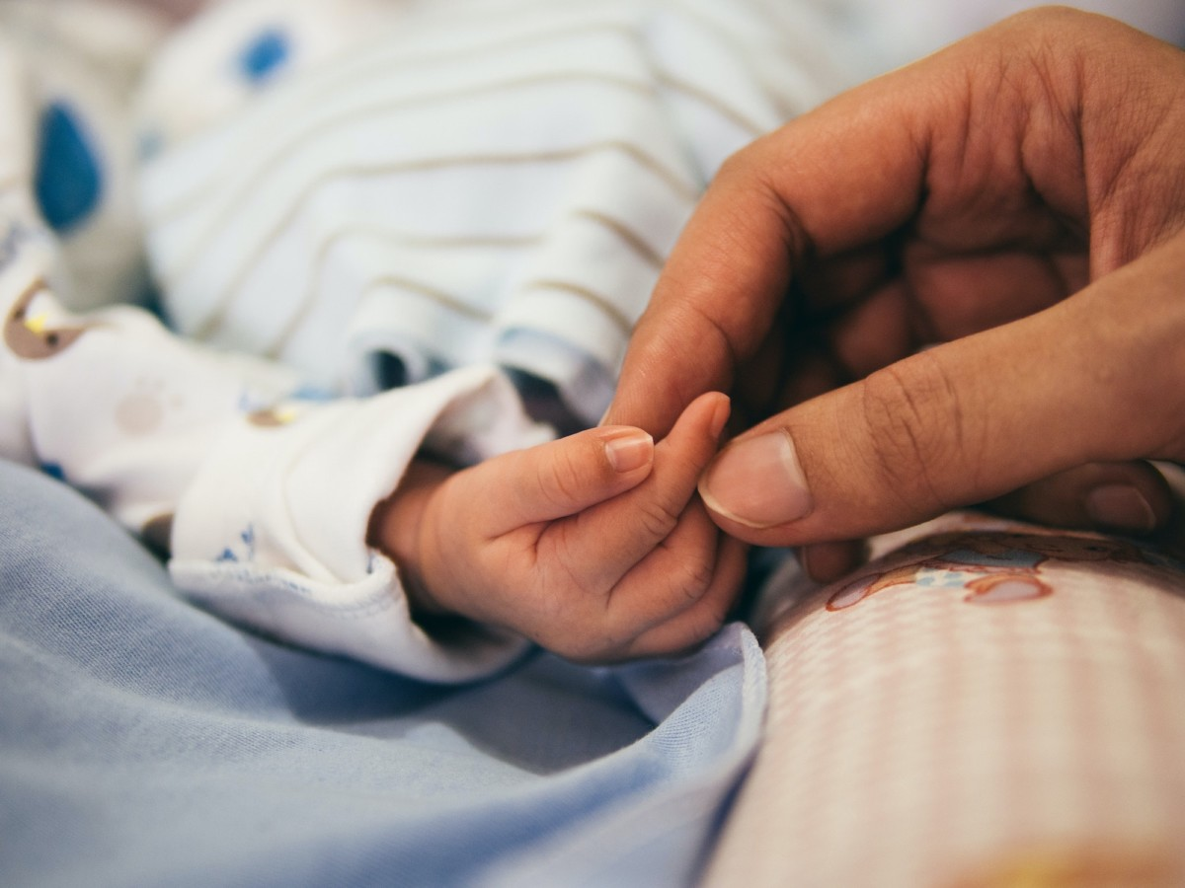
2. Infant Observation
The focus of work during the initial phase of training is the Infant Observation. You will be allocated a place in an intimate seminar group with a small number of fellow trainees.
You will need to organise to engage with an expectant mother and her family prior to delivery. After the birth of the baby, you will visit the family weekly for at least twelve months. Careful recordings of the observations made during the visits must be kept for detailed consideration in the weekly small group supervision sessions with your seminar leader.
Trainees are encouraged to remain with their group until the other babies in the group have reached twelve months of age. The Infant Observation seminars run for one and a half hours and are held at a time specified by the particular seminar leader.
The discipline of being an attentive observer of a developing relationship, which involves intense and often primitive feelings, provides a solid and crucial foundation for involvement with the types of emotional states frequently evoked in the clinical situation.
Successful completion of infant observation and capacity to observe and reflect are required to be achieved before progressing to clinical cases.

3. Case Supervision

Following successful completion of infant observation trainees are required to complete two supervised clinical cases.
- A case seen at least twice weekly for two hundred hours, or over two years, whichever is longer, and individually supervised once weekly.
- A case seen at least twice weekly for one hundred hours or for one year, whichever is longer, and individually supervised once weekly.
Each case is to be supervised by a different supervisor
Selection of Patients: Trainees are responsible for finding patients suitable for psychoanalytic psychotherapy. Selection of suitable patients will be considered in depth with the trainee’s approved supervisor.

4. Theoretical / Clinical Seminar Program
The format for the theoretical/clinical program is a seminar/tutorial style of learning. You will receive reading material, such as clinical papers, texts, case histories, before the seminar. Each trainee is expected to read and be prepared to discuss the references. Seminar leaders and trainees are encouraged to introduce suitable clinical material to illuminate the theoretical material in the group discussions.
You will also be given the opportunity to present case material from your own clinical practice to the training group under the guidance of a senior NSWIPP member, concurrently with the theoretical program. A principle of spiral learning is followed whereby the same topic is reworked from different perspectives during different stages within the course to encourage a deepening understanding of the material. Seminars are held on a Wednesday evening and run for three hours.
Curriculum
Our curriculum, which there is an example of on our website www.nswipp.org, is regularly updated, and the contents of the theoretical program available are intended only as a guide. The weekly three-hour seminar format is divided currently into theoretical and clinical sections, and the seminars are held during the academic term.

ASSESSMENT
There is ongoing assessment of your progress as a trainee, and formal evaluation occurs every six months. The completion of each stage of the training gives both the you as a trainee and the ATAB an opportunity to consider whether you have met the requirements for progression to the next stage of the training. This is particularly important at the end of the Infant Observation year.

Application and Selection
A Selection Subcommittee manages the application process. Once your application has been received two interviews will be arranged separately with senior members of NSWIPP. The interviews provide an opportunity for you to discuss your application and the training in depth. Applicants are asked to include with their application evidence of membership of their professional body and a copy of their Professional Indemnity Insurance.

SUPPORT FOR TRAINEES
Upon acceptance into the training program, you will be assigned a Trainee Advisor (TA) for the duration of the training. The Trainee Advisor is a representative of the ATAB. This relationship provides a personal point of contact for the trainee and a link with the ATAB. You and your allocated TA will meet each term to review your progress and raise or address any specific issues that have arisen, including feedback to and from the ATAB.

PROGRESSION TO MEMBERSHIP OF NSWIPP
It is hoped that all trainees who successfully complete our Training Course will apply to the Membership Advisory Board of the NSWIPP to become members of the Institute. Upon successful completion of the training course, and while trainees prepare to apply for membership, they are invited to join the Institute’s “Guest List” giving trainees the opportunity to participate in, and contribute to, the scientific life of the Institute and provide support during the membership application process. Trainees are also assigned a Mentor who will guide the trainee through the process of preparing for membership Presentation.

COSTS
The major costs for trainees in this course will be those of the individual case supervision and personal therapy. The costs for these are negotiated between the trainee and their supervisor/s and therapist.
The current cost of our Seminar Training Program is $148.50 (plus GST) per three-hour theoretical/clinical seminar, and this fee is reviewed annually. There are four terms per year and usually eight to ten seminars per term. The current cost of the Infant Observation is $132.00 (plus GST) per seminar, and this fee is reviewed annually. All costs for the required training are tax-deductable.

FURTHER INFORMATION
Further information about NSWIPP and our training course is available by contacting the Chair of the ATAB via the Administration Officer nswipp4@bigpond.com .
Further information about the selection process is also available by contacting the Chair of the Selection Subcommittee via the same email address. More information about NSWIPP can be found on our website www.nswipp.org, including a detailed example of our Curriculum click here

Document Version | Responsible Person | Reivew Date
Version 1.1  July 2024 | Julie Fletcher  Chair ATAB | July 2028

